Buddy poppy requirements for FY 23-24 and Beyond.

Buddy poppy requirements for all state and all American.

Each post who desires to participate in the All state and all American program will be required to purchase a minimum of 3 poppies per member of their Post (VFW Member) or 500 poppies (minimum order per post).

The Post has the option of Purchasing the New Tin Tab Poppy, or the Legacy Poppy.

The cost for the Tin Tab poppy is estimated at $60.00 per 500 plus shipping ($12.00) for a total of $72.00.

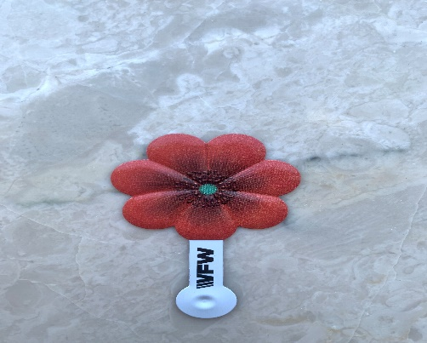

Tin Tab Poppy

The Cost for the legacy poppies will be $125.00 per 500, plus shipping ($17.00) for a total of $142.00.

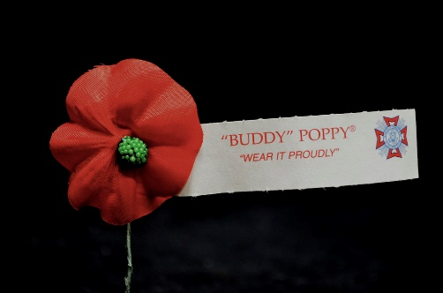

Legacy Poppy

Each Post ordering Poppies will submit the following form to the Department QM. (See Below) The Department QM is the only person who can order Poppies for the Post in their department.

DEPEPARTMENT OF Nevada VFW BUDDY POPPY ORDER FORM
 |  |  | ORDER #
SHIP TO ADDRESS: No PO Boxes. UPS does not deliver to PO Boxes. | TIN TAB or Legacy Poppy | POST NUMBER | DATE REQUIRED | QUANTITY REQUESTED

VFW Store Shipping Cost

SHIPPING & HANDLING
Up to $10.00 .................... Add $4.00
$10.01 to $25.00 ..................... $7.00
$25.01 to $50.00 ..................... $9.00
$50.01 to $75.00 ................... $12.00
$75.01 to $100.00 ................. $15.00
$100.01 to $200.00 ............... $17.00
$200.01 to $300.00 ............... $19.00
$300.01 & Over ..................... $24.00
Prices effective through 8-31-23

